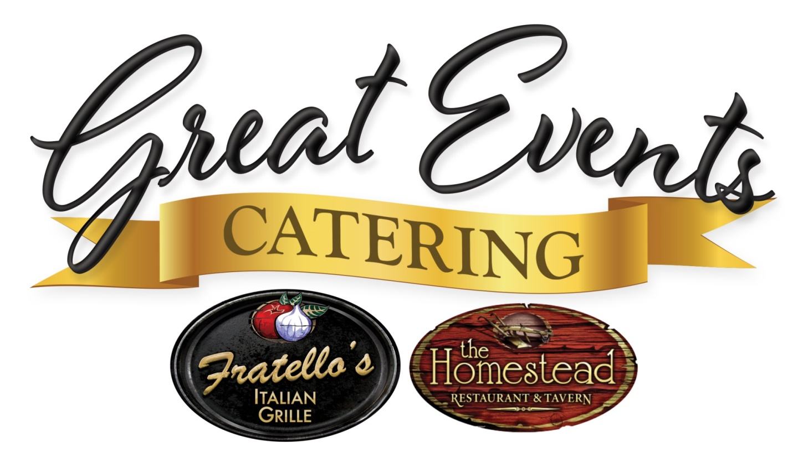

2019 Wedding Catering Manual

*Congratulations!*

*Congratulations to you on your engagement and thank you for considering Great Events Catering for your wedding caterer. Your choice of the wedding food is one of the most important decisions you will make for this day and we are honored you have thought of us during this process.*

*Why Great Events Catering?*

*Great Events Catering is the catering department of the Fratellos & Homestead Restaurants, a popular NH restaurant chain. While our restaurants specialize in both Italian and country home favorites, we offer much more than that on our menu. Our culinary team has an extensive background in the food industry; working in resorts all over the state and striving for perfection in all that they serve. As you will see from the following menus, our packages offer a variety of traditional and creative options guaranteed to satisfy your guests’ palettes. Looking for a certain ethnic flavor? Our chefs enjoy being creative and providing you with a menu that will complete your wedding day dream.*

*We are confident that with Great Events Catering you will receive both a high quality product at an affordable price and a distinctive service experience that will complete your wedding day dreams. After you have had an opportunity to review the enclosed information, please feel free to contact us with any questions that you may.*

*Thank you and congratulations once again on your engagement.*

*We look forward to speaking with you soon!*

*The McDonough Family*

*Plated Wedding Menu $52.99 per person*

*Our basic plated wedding package includes two entrees of your choice plus a vegetarian option, fresh salad with warm rolls, complimentary wedding dessert cutting and coffee and tea buffet.*

*International and Domestic Cheese & Fresh Fruit Display*

*Salads*- (choose one)

*Crisp Garden Salad with Zinfandel Vinaigrette*

*Classic Caesar with Housemade Dressing*

*Caprese Salad with Balsamic Drizzle*

*Chef Seasonal Salad with Housemade Vinaigrette*

*Entrée Selections*(choose two) (*Vegetarian & Children Entrees on last page)*

Mediterranean Stuffed Chicken *airline chicken stuffed with feta, spinach, sundried tomatoes and boursin with aglio olio sauce; paired with wild rice pilaf and grilled asparagus spears*

Chicken Marsala *atop roasted garlic mashed potatoes and sautéed string beans and shallots*

Chicken Milanese *lemon sage beurre blanc, paired with citrus feta orzo and seasonal squash blend*

Chicken Canneberge(+$3pp) *airline chicken stuffed with a cranberry and Brie stuffing with pan gravy; served with green bean almandine and a rosemary garlic mashed potato*

Gorgonzola Steak Tips *bourbon glaze, gorgonzola cheese, paired with roasted red potatoes and seasonal squash medley*

Chianti Braised Short Ribs (+$3pp) *atop smashed russet potatoes and roasted root vegetables*

Tenderloin of Beef(+$6pp) *7 oz roast tenderloin, drizzled with bordelaise sauce, served with mushroom risotto and fire roasted brussels & grape tomatoes*

Five Spice Pork Loin *maple cream; served with wild rice pilaf and roasted squash, spinach and pancetta medley*

Poached Salmon *blood orange beurre blanc or sundried tomato vinaigrette, with roasted fingerlings and sautéed spinach*

NE Style Haddock *panko crumbs, white wine, lemon butter sauce; served with roasted red potatoes and broccolini*

Baked Stuffed Haddock (+$3pp)  *lobster, shrimp & scallop stuffing, topped with Newburg sauce; served with roasted red potatoes and broccolini*

Veal Piccata (+$4pp) *lemon sage beurre blanc, capers, paired with citrus feta orzo and seasonal squash blend*

Baked Salmon Oscar (+$8pp) *broiled filet, topped with lobster meat, asparagus and béarnaise; served with roasted fingerlings and sautéed spinach*

Surf & Turf (+$10pp) *6 oz roast tenderloin of beef, paired with poached salmon; served with rainbow potato medley and grilled asparagus spears*

In Harmony (+$5pp) *herb roasted airline chicken and gorgonzola tips, paired with garlic smashed potatoes and sautéed string beans & shallots*

### 

**Sliced Seasonal Fresh Fruit $5pp**

**Artisan Cheese $4pp**

International and Domestic Cheeses- Assorted Crackers & Crostinis- Fresh Fruit Garnish

**Dip Trio $6pp**

Choose three, served in bread bowls with toasted pita triangles

* + Crab and Cream Cheese
  + Spinach and Artichoke
  + Tzatziki
  + Roasted Garlic Hummus
  + Black Olive Tapenade
  + Black Bean & Corn Salsa with blue and white corn chips
  + Salsa Verde w/ blue and white corn chips
  + Mango Pineapple Salsa w/ blue and white corn chips

****Antipasto $9pp****

Marinated Artichoke Hearts- Genoa Salami- Prosciutto- Roma Tomatoes- Buffalo Mozzarella-- Grilled Pesto Chicken- Olives

****Middle Eastern**** **$9pp**

Hummus- Roasted Red Peppers- Black Olive Tapenade- Baba Ganoush – Greek Olives- Tabouleh- Marinated Feta - Toasted Pita

**Charcuterie $9pp**

Soppressata- Cured Sausage- Prosciutto- Dried Apricots- Tapenade- Whole Grain Mustard- Roasted Red Peppers- Dry Cheeses- Breadsticks- Toast Points

**Cold**

**Bruschetta Spoons** mozzarella fettucine-crouton-balsamic drizzle **$70**

**Roasted Fig Tartlet** goat cheese- honey drizzle **$75**

**Golden Gazpacho** tortilla spoon **$80**

**Salmon Canape** fingerling potatoes-smoked salmon- crème Fraiche **$85**

**Antipasto Skewers $85**

**Proscuitto Wrapped Asparagus $75**

**Fresh Fruit Skewers** honey vanilla yogurt dip **$85**

**Sake Cured Tuna** crispy wonton  **$85**

**Buffalo Chicken Bites** phyllo cup- bleu cheese crumble **$80**

**Caribbean Smoked Fish Dip on Taro $85**

**Jumbo Shrimp** with virgin bloody mary shooter **$150**

**Caprese Skewers $85**

**Pesto Cream Cherry Tomatoes $60**

**Chicken Mouse on Cheddar $75**

**Beef Tenderloin Crostini** horseradish chive cream **$100**

**Beef Negimaki** asparagus -thin roast beef- boursin spread **$90**

**Hot**

**Spinach and Feta Mash**  phyllo cup **$ 75**

**Spinach & Red Pepper Mushroom Caps $ 75**

**Vegetable Dumplings** miso teriyaki sauce **$ 85**

**Black Bean Cake** cilantro cream **$ 80**

**Grilled Cheese Triangles** with tomato soup shooter **$ 70**

**Coconut Chicken Tenders** sweet and spicy chili sauce **$ 80**

**Fingerling Skins** gorgonzola & pancetta cream **$ 85**

**Beef Wellington**  demi glaze **$ 110**

**Deconstructed Burger Skewer** roasted garlic aioli  **$ 85**

**Sesame Satay**  beef or chicken- thai peanut sauce **$ 75**

**Maple Apple Sausage Mushroom Caps $ 85**

**BBQ Pork Crostini** caramelized onion jam  **$ 85**

**Crab Cakes** roasted red pepper remoulade **$ 110**

**Jumbo Sea Scallop** maple bacon jam **$ 125**

**Chicken & Waffles** spicy maple reduction **$ 85**

**Priced per 50 pieces**

Recommendation: 4-6 pieces per person with dinner 8-10 pieces per person for hors d’oeuvres party

Children’s Pricing (age 4-11 years)

Plated Entrée $13.00 per person

Menu options include: Grilled Chicken with Mac & Cheese, Chicken Tenders & Fruit, Penne Pasta w/ Marinara & Meatballs

Buffet Options $20 off the buffet package price when eating off the buffet

Vendors

We are happy to provide a free meal for your vendors off the buffet. We will offer a flat $20 meal charge for any plated vendor meals.

Tastings

If a tasting is requested, we will be happy to accommodate at one of our restaurants or in our banquet facility in Manchester. Appointments must be made ahead of time.

Contact

Samantha Limoges, Offsite Catering Director

603-581-9022

[www.greateventsnh.com](http://www.greateventsnh.com)

[Samantha@fratellos.com](mailto:Samantha@fratellos.com) or [info@greateventsnh.com](mailto:info@greateventsnh.com)